Anterior Cruciate Ligament Reconstruction Information Sheet

Dr Steven A. T. Krywulak MD, FRCS(C)

The following handout is intended to provide general information for patients considering anterior cruciate ligament (ACL) reconstruction. The nature of the condition as well as options for treatment is discussed. If you have further questions, please contact your surgeon.

1.) What is the anterior cruciate ligament (ACL)?

There are two broad ligaments found in the center of the knee. These are the anterior and posterior cruciate ligament. They are called cruciate ligaments because they cross one another. Both of these ligaments help connect the femur and tibia bones in order to prevent forward and backwards shifting of the two bones on each other. The ligaments also function to stabilize the knee during pivoting or twisting of the knee. Of the two cruciate ligaments, the ACL is much more frequently injured than the PCL.
Front of Knee
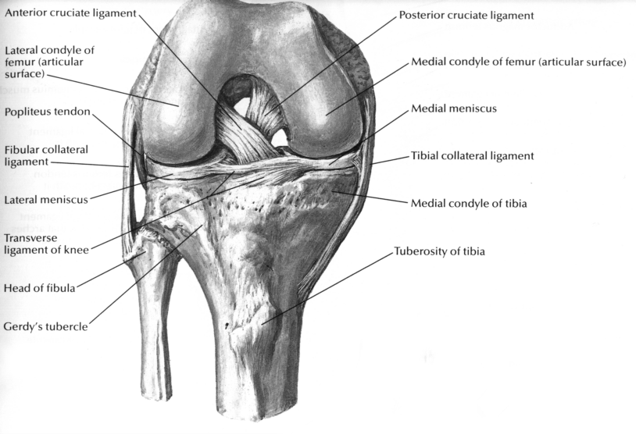
Back of Knee

2.) How is the anterior cruciate ligament torn?

There are many different ways that a patient can tear his/her ACL. One common mechanism is a very strong quadriceps muscle contraction with the leg fixed (i.e. Falling backwards while skiing and not having the bindings release). Twisting injuries of the knee or collisions during high intensity sports can also result in a torn ACL. Some patients will tear their ACL as part of a major trauma and this may be only one of the ligaments torn if the knee is dislocated.

3.) How do I know if I have torn my ACL?

Initially, at the time of injury, the knee usually swells immediately. A pop or snap may be heard as well. Walking may be difficult for a few weeks and most patients require crutches for 2-4 weeks after the injury. The knee will be stiff and sore but in most cases it will settle down in 6-12 weeks. Some patients will have milder symptoms with a more rapid recovery.

Once a patient resumes activity or sports, they will most often complain of instability or giving way of the knee. Often a patient will notice this instability most on uneven ground or with twisting/pivoting activities. When the knee gives way, the knee can often swell afterwards and most patients can be disabled again for several weeks. Over time, instability can reoccur frequently with simple activities of daily living and can have a negative impact on a patient’s quality of life.

An emergency doctor or your family doctor may be able to diagnose an ACL tear in their office. If they suspect a tear or are unsure, a referral to an orthopaedic surgeon will often be made. Most ACL tears can be diagnosed by some simple physical exam tests. X-rays are always required but often are not all that helpful and are usually normal. An MRI (magnetic resonance image) scan is a very accurate test for diagnosing ACL tears, but MRI not readily accessible in our health care system due to long waiting lists. MRI scans are typically only used if the diagnosis is still in question or if the surgeon is looking for other pathology in the knee, such as cartilage damage, meniscal tears or other ligament tears.

4.) How are ACL tears treated?

In the acute phase, the initial goal of therapy is to rest the knee using crutches and control swelling. Ice, anti-inflammatories and compression with a tensor all help to reduce swelling and pain. Once the inflammatory phase has started to subside, the goal of therapy is to regain full range of motion of the knee and strengthen the muscles around the knee. The hamstring muscles are particularly important in stabilizing a knee with an ACL tear. Often the help of a physiotherapist is useful in directing a patient’s rehabilitation. Once the therapy is complete, consideration is given towards obtaining a hinged knee brace designed specifically for ACL deficient knees. Surgery to reconstruct the anterior cruciate ligament may also be considered.

5.) Can the ligament be repaired or will it heal over time?

The answer to both of these questions is no in most cases. The ligament itself will not heal to any significant extent. Only in rare cases where the ligament has pulled off a large piece of bone with it, would consideration be given to trying to repair the injury. Most ACL tears consist of the ligament pulling off of the bone itself or by the ligament tearing in the middle.

6.) Should I get a brace, and if so, what kind should I buy?

There is no right answer to this question. The decision to purchase a brace is a personal one made by a patient in conjunction with the advice obtained from their health care providers. Firstly, no study has ever proven that custom hinged ACL braces prevent re-injury either before or after surgery. An unstable knee can still give out with a brace on. The reason for this is that a brace attempts to control extreme forces occurring at the knee joint by holding the bones from a distance through a large soft tissue envelope (i.e. the thigh muscles). However, many patients find that their brace gives them more confidence in their knee and subjectively find that it seems to help with stability. In patients that place low demands on their knee, a brace alone may suffice as treatment. Bracing can be helpful if a patient is on a long waiting list and requires some extra stability for work activities or other special situations. A brace can also be helpful postoperatively to help a patient make the transition back into sports or work.

Custom braces are specially fit to a patient’s thigh and leg but are quite expensive. They tend to average about $1200.00. Several companies supply ACL braces and all come with slightly different materials and features. No one is clearly superior to another. The brace chosen should reflect patient demands and preferences. You should consult the orthotics professional fitting your brace to help you choose which one is right for you. Be sure to buy from an experienced and reputable professional dealer. Your surgeon can usually refer you to someone who has provided patients with good service in the past. Most companies now offer a more affordable “off the shelf” ACL brace in a few standard sizes that can be fit to most patients. These less expensive braces cost about half the price of a custom fit brace but may do an adequate job in many patients.

7.) Do I need surgery to reconstruct my anterior cruciate ligament?

An ACL reconstruction is a major operation with a significant postoperative recovery period. The goal of surgery is to make the knee more stable and hopefully prevent future giving way episodes. The surgery does not make the knee normal or as stable as it was prior to the injury, but it comes close. Most patients are satisfied with the stability and confidence that the surgery provides. About 40-50% of patients will be able to resume sports/activities at the same level as before surgery. Roughly 20-30% will resume previous activities but at a lesser level of intensity. That leaves 20-30% who do not make it back to their previous activities. A graft can stretch out over time or rupture resulting in further instability.

If a patient has an ACL tear, but places low demands on the knee and does not have giving way, they may not require surgery. If a patient has mild clinical instability, but can do everything he/she wants to in a brace, they too may not need surgery. Ultimately, a patient must decide if the benefits of surgery outweigh the potential risks. A patient having ACL reconstruction must also be committed to following the intense rehabilitation protocol following surgery.

A final consideration may be arthritis in the knee. It has been well established that patients with ACL tears will usually go on to develop significant arthritis in their knee over 20 to 30 years. No one knows for sure if stabilizing the knee with an ACL reconstruction will prevent arthritis. There is general agreement that recurrent episodes of giving way can damage cartilage in the knee and contribute to arthritis. We hope that by reducing these episodes, the knee will have some protection against further damage. This is often why surgery is strongly suggested for young patients in their 20’s and 30’s.

8.) How exactly is the procedure done?

The surgical technique may vary considerably between surgeons. It is up to your surgeon to use the technique that he or she is most comfortable with.

On the day of surgery, you will be given either a general anesthetic (put to sleep) or a spinal anesthetic (freezing in your lower back to numb your legs). Your surgeon will examine your knee under anesthesia and then the leg is cleaned and prepped for surgery. A tourniquet may be applied to your thigh to help reduce blood loss during the operation.

My preference is to use two of the three hamstring tendons on the inside of the leg as a graft material. Some surgeons use the middle one third of the patellar tendon as a graft. Both graft types have shown equivalent results in long term follow-up. The tendons are harvested from a small incision just below the knee. The two tendons are then looped on themselves making a four bundle graft.

Three small stab incisions are then placed on the knee for the arthroscopic surgery portion of the procedure. The knee is inspected for any damage such as cartilage or meniscal tears and appropriate measures are taken to address the pathology in the knee. The old ACL stump is then removed and drill holes are made in the tibia and femur bones precisely where the old ACL used to run. The graft is then brought up through the holes and tensioned and secured, giving the patient a new functional ACL. I personally use something called an exo-button to fix the graft at the femur. This is a very strong method of fixation and saves the patient another incision above the knee. The graft is secured at the tibia with an absorbable interference screw to hold the graft tightly and prevent loosening

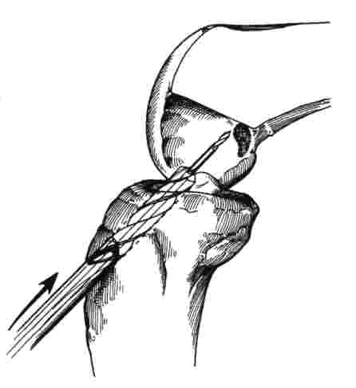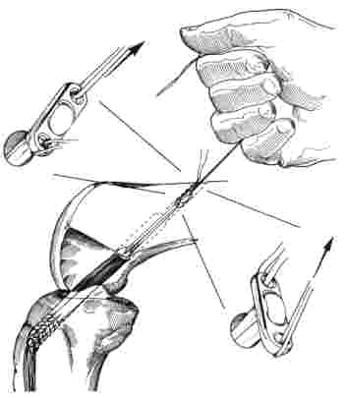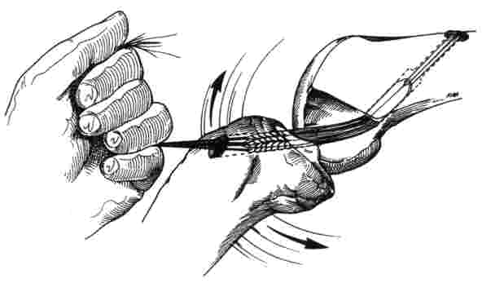

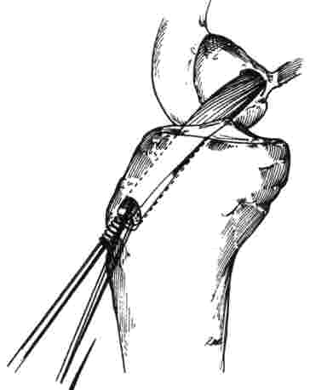
The incision below the knee is then stitched and the arthroscopy portals are closed. The knee is dressed with bandages and a cooling unit is applied. The patient is taken to the recovery room for a short time and finally ends up on the ward. Patients have the option of going home the same day or staying in hospital for one night.

9.) What are the risks or complications typically associated with ACL reconstruction?

All operations have inherent risks, but fortunately complications with ACL reconstruction are quite rare. The following list of complications includes the most common problems that can be encountered, but may not include every possible complication. If you have any questions or concerns, you should discuss them with your orthopaedic surgeon before surgery.

- Infection (all patients receive antibiotics prior to surgery).
- Excess postoperative bleeding.
- Nerve damage around the knee (saphenous or popliteal nerves).
- Damage to the large blood vessels in the back of the knee.
- Numbness on a small area of skin near the graft harvest incision (almost always happens, can resolve over time).
- Postoperative knee stiffness (difficulty full flexing or extending knee).
- Blood clots in the large veins of the knees.
- Reaction to the anesthetic drugs or other drugs/antibiotics given during surgery.
- Recurrent instability of the knee post-operatively or re-tearing of the graft.
- Symptomatic hardware used to secure the graft (requiring later removal of hardware).

Every attempt is made to avoid these complications and most of them can be dealt with appropriately if they are recognized early.

10.) What happens after the surgery?

For the first few days, patients typically take it easy and keep the leg elevated. Crutches are necessary for 3-4 weeks to help keep inflammation down in the knee. Range of motion exercises are started immediately. A cooling unit is used to control pain and swelling and a hinged rehabilitation brace is used to assist with walking.

Formal physiotherapy is strongly recommended early in the postoperative period. It is actually possible to do damage to the graft if you do the wrong types of exercises, so some instruction is necessary. Patients are usually seen at 7-10 days after the surgery and again at 6 weeks. Three month, six month and one year follow-up visits are standard.

The following is a rough guideline of what to expect with regards to return to activity following surgery. All patients differ in their rates of recovery, but certain activities should definitely be avoided until the appropriate interval in order to prevent stretching or damage of the graft. Return to activity is coordinated between the patient and his/her surgeon and often individualized.

- partial weightbearing on knee immediately, progressing to full weightbearing by 2 weeks
- physiotherapy to start the first week postoperatively
- discontinue crutches at 2-4 weeks
- stationary bicycle exercising at 4-6 weeks
- swimming by 3 months
- jogging by 4-6 months
- fit for brace at about 6 months
- early return to sporting practice (depends on sport involved) – minimum 3 months, usually 6-9 months
- full return to sports 9-12 months

Return to work is also individualized based on demands placed on the knee by the patient at work and patient progress. Usually a common sense approach is taken which emphasizes safety for the patient and their ACL graft.

